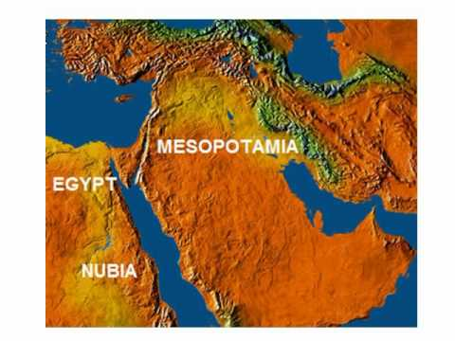

CLICK HERE
Click and find the answers to the following questions about Mesopotamian civilizations. Follow the link to the cities Assyria, Babylonia and Sumer in the web.

- Who was Aplum?
- How long was the Babylonian calendar ?.
- How did Aplum know that a new month was beginning?
- How was grain mainly transported?
- What did coracles transport?
- How did they transport pearls and stones?
- Where did King Sennacherib decide to build a palace in Assyria?
- What precious metals were used for the construction of this palace?
- What guarded the doorways of the temple?
- Why was a canal was built from the mountains to the orchards?
- Who was Sennacherib?
- Why did king Hezekiah of Judah rebel against Sennacherib?
- How did the Assyrian army the Assyrian army protect their camps?
- How could they transport their heavy equipment right up to the walls and gate?
- How did the men in Lachish defend the city’s tower?
- What was E-hur-sag?
- What made the Royal Graves different to other graves?
- How many Royal Tombs did Woolley and his team find?
- In the Royal Tombs in Ur, why do the tomb names start with the letters PG?
- What was a ziggurat?
- Where did the first ziggurats appear?
- What are weeper holes in ziggurats?
- What was on top of the ziggurat?

ANSWER KEY
- An astronomer from ancient Babylon.
- It had 12 months of 29 or 30 days, a total of 354 days
- When Aplum saw the moon set on the western horizon at sunset
- On boats
- Meat, grain, reeds and fish
- By gulf boats
- at Nineveh
- cedar wood and ivory
- Large stone statues of human-headed winged bulls and lions
- Because there wasn't enough water
- the ruler of the great Assyrian empire.
- Because he refused to pay tribute
- They surrounded them by walls with towers
- The army built ramps leading up to the city so that they could transport their heavy equipments.
- The men defending the city's towers used bows and arrows and stones to keep their attackers away
- a large square building with many narrow rooms. It was a shrine and home for priests.
- In most of the other graves the dead person was wrapped in reed mats and surrounded by objects like pottery, cups and small amounts of jewellery. The 'royal' graves had proper tomb chambers which were filled with objects made of gold, silver and precious stones.
- 17
- Each tomb number starts with PG for 'private grave'
- a huge platform with a series of smaller platforms on top. It looked like a stepped pyramid with stairs leading to the summit where there was a small temple
- In Sumerian cities.
- Small holes in the ziggurat walls to allow water to evaporate from the core
- The temple

