EGYPT AND MESOPOTAMIA :TREASURE HUNT
In the following links you will find the answers to the questions below, listen and complete:
https://www.youtube.com/watch?v=KdtgX9ORiW4 The ancient Egypt: National Geographic 3:08´
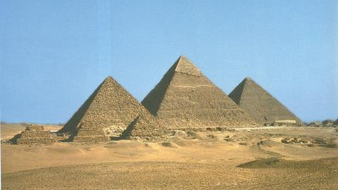
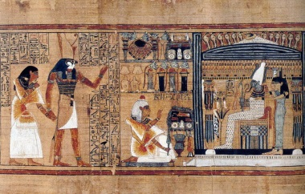 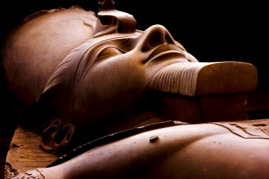
1) When was created The Ancient Egypt around the Nile River?
2) It was ruled by the pharaohs for more than 3000 years and what did they develop?
3) Which 3 things did Egyptians create?
4) Who was the God of the Dead for Egyptians?
5) Egyptians believed in life after death and they embalmed important people with their dearest objects such as:………………………………………………
https://www.youtube.com/watch?v=DCjtPRHRZs8 THE DEVELOPMENT OF WRITING IN MESOPOTAMIA 2:11´
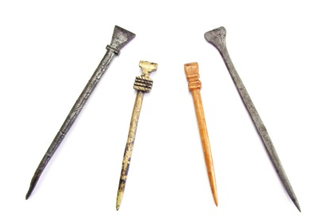
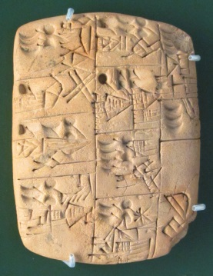
- Why did writing begin?
- What did Egyptian write?
- They started writing little pictures which represented words…and when people became faster, what did they start to use?
- Egyptians style of writing was called C…………………………………, that means wedge-shaped ( en forma de cuña).
- Which tool, cut from leaves that grew along the Nile, did they use for writing?
- Where did they write on?
https://www.youtube.com/watch?v=WBlwUM9uFes EGYPTIAN MUMMIFICATION PROCESS 3:33´
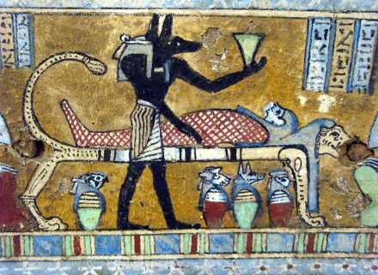
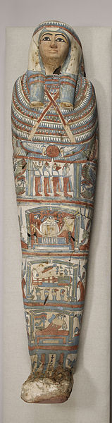
Early Ancient Egyptians would their dead in the desert sand, which would dry out and preserve the bodies. Later they began to bury them in coffins to protect them from predators; but soon they realized that, without the sand and dry, the bodies would decompose and over the centuries they developed the process of m…………………………..
- Mummification began with embalming, first the body is washed with palm wine and water from the N……………
- Second, a cut is made in the left side of the body and the organs are removed with the exception of the h………………….., because it was believed to be the source of intelligence.
- The brain was thought to have no use and was removed through the n………………………..
- The body was covered with sawdust ( serrín) to be dried out for 40 days and then is again washed with water from the Nile and the body was rubbed with oil to stay e……………………….
- The dried organs were used to be placed inside the body again, which was filled with sand dust and l…………………., and rubbed with o………………….. perfumes.
- What did the embalmers put next to the bodies to protect them in the afterlife?
- Which book did they also used to wrap to the body?
- Where is the body placed next? In a coffin and within a s……………………………… inside the tomb.

