PREHISTORY SCAVENGER HUNT
In the following links you will find the answers to the questions below, listen and complete:
https://www.youtube.com/watch?v=Mm-IxK1GrYE HUMAN PREHISTORY:PROLOGUE
https://www.youtube.com/watch?v=xnZWMOpmoRk#t=21 HUMAN PREHISTORY(1): OUT OF AFRICA
https://www.youtube.com/watch?v=T9Nw66RCMhg HUMAN PREHISTORY(2): WEATHERING THE STORM
https://www.youtube.com/watch?v=IVHD9wGlbho HUMAN PREHISTORY(3): AGRICULTURE ROCKS THE WORLD
(prologue) https://www.youtube.com/watch?v=Mm-IxK1GrYE

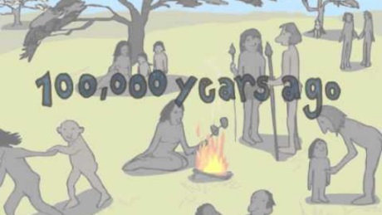
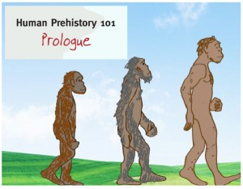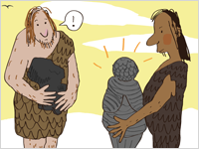
- Look for the similarities and differences between man and chimpanzees.
- Our ancestors´skulls developed and were used more to _________________ and less to _________________
- When did we first find bones from people in Africa?
- Which are the names of the first 3 stone tools used, according to the video?
- As a result of migrations, Homo Sapiens was not alone, they shared the planet with _________________ who lived across Asia. At the same time ______________ lived across Europe, Western and central Asia.
- Homo Erectus´features: _______________, ________________, ______________ and ____________.
- Neanderthal´s features: _______________, ________________, _________________ and ___________________: ( cared for their sick and ______________________)

(OUT OF EASTERN AFRICA) https://www.youtube.com/watch?v=xnZWMOpmoRk#t=21

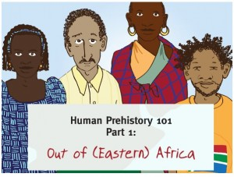
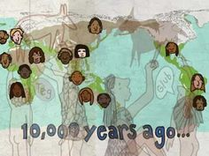
- How much did our ancestors walk about 60,000 years ago?
- About 50,000 years ago people created more sophisticated tools such as ____________, ______________ or _____________ and devoted to __________.
- A few thousand years later, the weather became _______________ and humans who had travelled from Africa to Asia found impossible to come back.
- 45,000 years ago people also lived in ______________ making their mark there.
- 35,000 years ago Neanderthals were confined to the ___________________________-and sooner after (25,000) they had _________________.

(WEATHERING THE STORM) https://www.youtube.com/watch?v=T9Nw66RCMhg
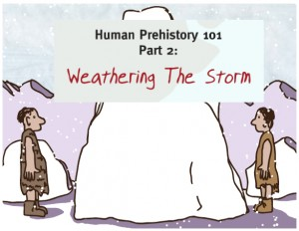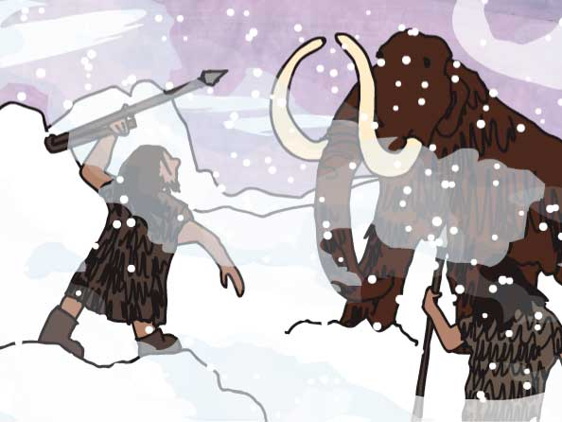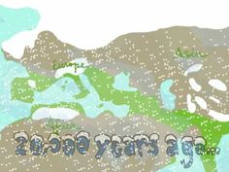
- 20,000 years ago the world suffered in the depths of the last ___________________.
- Global average temperatures decreased 15 degrees Fahrenheit, that´s about 8 degrees ______________ below what they are today.
- Balthic _______________ covered much of North America, Europe and Asia. Outside the ice-covered areas, it was so _______________ that survival became difficult in most areas.
- The Ice Age, not only created _____________ but also created ___________.
- Sea levels dropped and connected places such as ___________ and Alaska. A few people took advantage of this bridge and went first to Alaska and later on to ____________________.
- In just a short time, people from a small corner of Africa had populated all ___________ except Antarctica.
- And in their new homes, their _______________ began to differentiate and became the precursors of today´s languages.
- Due to extreme weather conditions, these people formed isolated groups and gradually became more _____________, _____________ and __________distinct from one another.

(AGRICULTURE ROCKS THE WORLD)
https://www.youtube.com/watch?v=IVHD9wGlbho
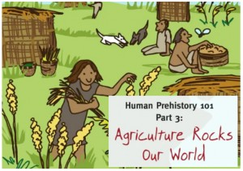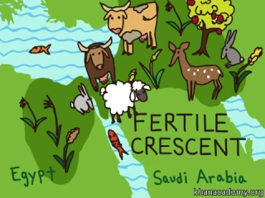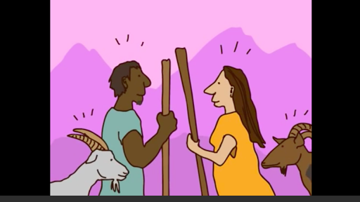
- By 14,000 years ago the Ice Age was winding down…. _____________and rainfall increased dramatically.
- And some areas, became so rich in plants and animals that people no longer had to travel in search of food, instead, people _____________ in more permanent _____________.
- As they had food, they left behind nomadic life and became _________________. All over the world they developed _______________.
- People also domesticated docile local ________________.
- Villages grew, especially in areas with good soil and became _____________.
- By 6,000 years ago, there were cities in Mesopotamia with _______________, _____________ and ________________.
- World´s population exploded creating more laborers who produced more ___________.
- Groups who had been separated for thousands of years, came in __________as they travelled in search of land, labour or trade goods.
- New means of _________________ brought distant cultures in contact, and the new families produced by this contacts brought genetic distinction between continents.
- But the Kallahari desert too harsh for farming, remained the home of ________________.

ANSWER SHEET
(PROLOGUE)
- SIMILARITIES: TOOL USE, OPPOSABLE THUMBS AND BEARDS/// DIFFERENCES: BIG BRAINS, ANATOMY,
- THINKING/CHEWING
- 200,000 YEARS AGO
- SPEAR HEAD, KNIFE AND SCRAPER.
- HOMO ERECTUS/NEANDERTHAL
- BIG BRAINS, HANDMADE AXEX, USE FIRE AND WEAR CLOTHING.
- BIGGER BRAINS ALSO USED STONE TOOLS, FIRE AND HAD STRONG SOCIAL RELATIONSHIPS. (BURIED THE DEAD).
(OUT OF EASTERN AFRICA)
- ABOUT 1 KM/A YEAR
- MICROLIT, BRADELET AND BONE POINT //ART
- DRIER
- AUSTRALIA
- SOUTH WEST CORNER OF EUROPE/DISAPPEARED
(WEATHERING THE STORM)
- ICE AGE
- CELSIUS
- GLACIERS/ DRY
- BARRIERS/ BRIDGES
- SIBERIA/NORTH AMERICA
- CONTINENTS
- LANGUAGES
- LINGUISTICALLY, CULTURALLY AND GENETICALLY.
- TEMPERATURES
- SETTLED/VILLAGES
- SEDENTARY/AGRICULTURE
- ANIMALS
- CITIES
- WEALTH, POWER AND NEW SOCIAL ORDER.
- CROPS.
- CONTACT
- TRANSPORTATION
- HUNTER-GATHERERS

