LISTENING COMPREHENSION
https://www.youtube.com/watch?v=JEgvbC8yDKE
https://youtu.be/JEgvbC8yDKE

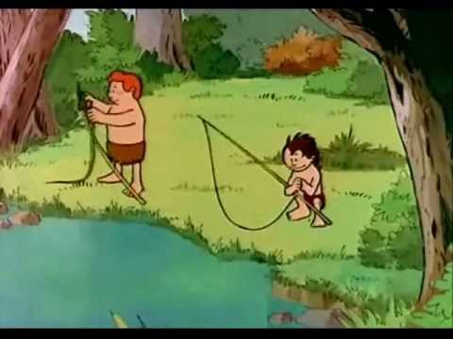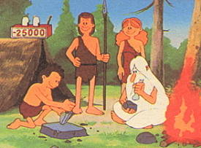

- There is a deal between the men in the tribes, what do they exchange?

- The first men built_______________ and also the first ___________ in history.
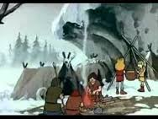
- The first stone tools the “teacher/chief” made are a __________ and a ________

- Where did the Cro-Magnon man draw?

- What were the animal skins used for?
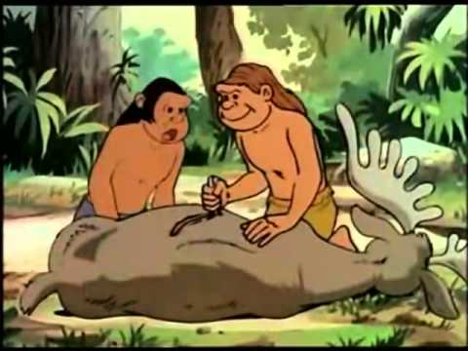

- What were animal bones and horns used for?

- What did they used dirt ( tierra/barro) for? 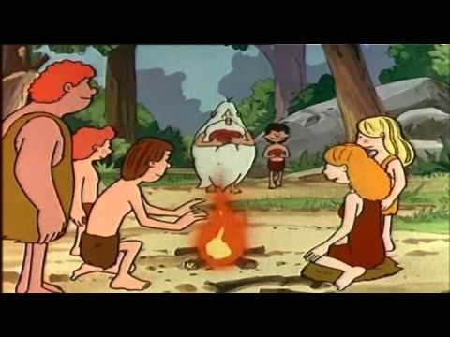

- For hunting big animals such as mammoths, they made_________ for them to fall in and then, they hit them with harpoons and stones to death.
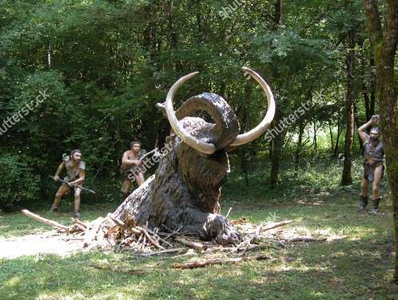

- Where these people sedentary or nomadic? Explain why.
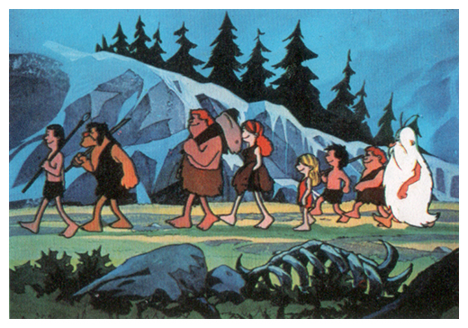

- Paintings in the wall were used to _____________________

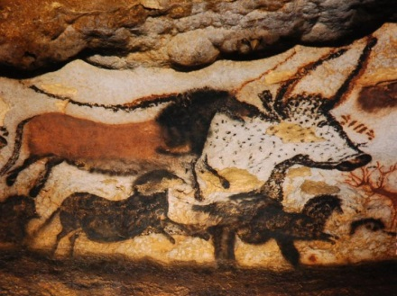

- They started cattles and ____________ animals.

ANSWER SHEET
- 2 mammoth skins for some stone tools
- (cabins)/ (wall)
- (blade)/ (hatchet).
- In the caves
- For clothing
- For tools as well as for ornaments
- For painting the faces of their hunting heroes, their companions (women), their chieftains, for covering their wall with artwork (paintings) and for colouring clothing.
- (traps)
- STUDENTS´OWN ANSWERS
- (represent huntings)
- (domesticated)

