ONCE UPON A TIME............THE FERTILE VALLEYS (listening comprehension)
https://www.youtube.com/watch?v=2OiEuu68Gh8
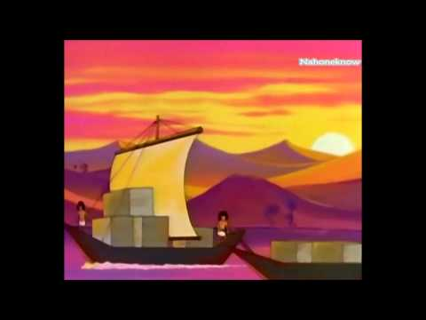
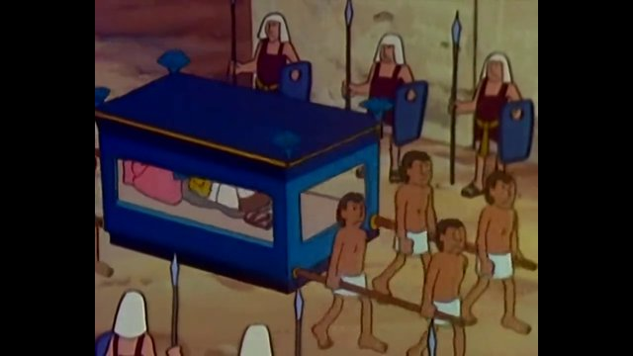
- (Minute 3:45) Europe was still in his Prehistory but, at the same time, higher civilizations were thriving(=prosperous) in ____________________ and in ______________.
- (7:33) The ________ that came was worse than anyone can remember.
- (8:09) The storms passed and _________________ becomes necessary once again…The problem is no one can agree on anything, each man works for himself, alone.
- (8:24) What was the name of men´s first writing?________________.
- _______________ ____________ told the story of this calamity ( flood), which one day would be called the Great Deluge, and history would repeat again and again.
- (9:34) What kind of building do they need to make so as to avoid floods to ruin everything?________________ to be used for agriculture and ______________ to protect villages.
- (10:47) What happened once flood was under control? The river brought F_____________, P__________ and P_____________.
- (12:44) What did priests, astrologists and scholars calculate?
- (15:00) How did the pharaoh want the pyramid to be built?
- (15: 24) Along the river _________________ centuries and dynasties came and went.
- (15:31) Who became King of the Nile in 1300BC?
- (16: 47) What happened to the farmers if they didn’t pay the taxes?

