MESOPOTAMIA ( 2:37 minutes duration) - Listening
https://www.youtube.com/watch?v=KY05g30v2Xo
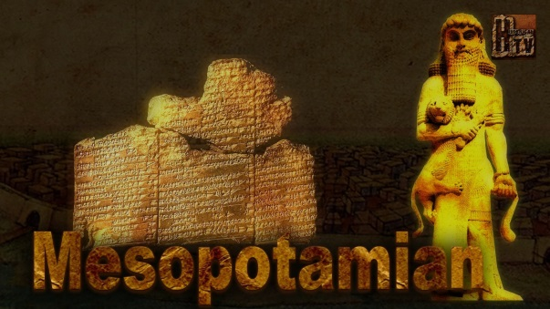
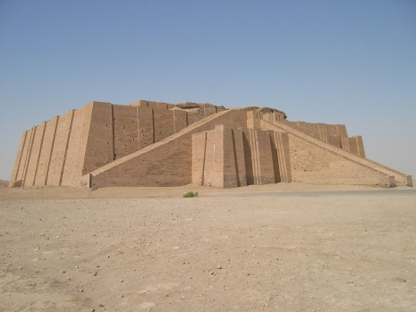
- Where does Mesopotamia take its name from?
- These two rivers formed what was called…?
- Mesopotamia is the place where nowadays we find……………………… ( name of a modern country)
- 10.000 years ago, the people in this zone lived in ……………….and built granary to ………………… their grain and began a simple system to take their accounts.
- Between 3500 BC and 3000 BC people moved and funded the cities of …………………….. and …………………………..
- And the P………………., the potter´s wheel and the introduction of B……….. can be seen as the responses to a demand of more economic life.
- In this same period came the beginnings of …………………….., metrological sytem and arithmetic.
- In the third Millennium, now called Early Dynastic period, the S………………………………… civilization developed and was based on numerous city states.
- The summerians had to face: floods, d………………………….., s………………………, dust, heat, disease and d…………………………

